Task 1 :
import java.util.Scanner;
class Item{
public String itemName;
public int itemId;
private int stock, Price;
public void setStock(int Stock1){
stock = Stock1;
}
public void setPrice(int price1) {
Price = price1;
}
public int getPrice() {
return Price;
}
public int getStock() {
return stock;
}
public Item (String ItemName, int itemId, int price ,int stock){
this.itemId = itemId;
this.itemName = ItemName;
this.Price = price;
this.stock = stock;
}
}
public class task1 {
public static void main(String[] args) {
double Total=0.0;
Item i1 = new Item("chips",1000,25000,15);
Item i2 = new Item("pepsi",1100,100,15);
Scanner sc = new Scanner(System.in);
System.out.println("Enter item id you want to purchase: ");
int itemid1 = sc.nextInt();
if (itemid1 == i1.itemId){
System.out.println("Item Name: " + i1.itemName);
System.out.println("Item Price: $" + i1.getPrice());
i1.setPrice(2300);
System.out.println("Updated Price: $" + i1.getPrice());
i1.setStock(50);
System.out.println("How many of them you want to purchase? ");
int quantity = sc.nextInt();
if (quantity <= i1.getStock()){
Total += (i1.getPrice()*quantity);
System.out.println("Grand Total: $" + Total);
}else {
System.out.println("you cannot purchase more items than available in stock.");
System.out.println("Quantity Available: " + i1.getStock());
}
} else if (itemid1 == i2.itemId) {
System.out.println("Item Name: " + i2.itemName);
System.out.println("Item Price: $" + i2.getPrice());
i2.setPrice(1500);
System.out.println("Updated Price: $" + i2.getPrice());
i2.setStock(25);
System.out.println("How many of them you want to purchase? ");
int quantity = sc.nextInt();
if (quantity <= i2.getStock()){
Total += (i2.getPrice()*quantity);
System.out.println("Grand Total: $" + Total);
}else {
System.out.println("you cannot purchase more items than available in stock.");
System.out.println("Quantity Available: " + i2.getStock());
}
}else {
System.out.println("Invalid Item Id!");
}
}
}

Task 1 Output:
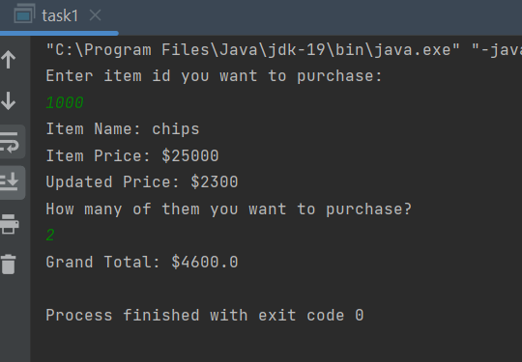
Task 2:
class Book{
private String title;
private String author;
double price;
public void setTitle(String Title){
this.title = Title;
}
public void setAuthor(String Author){
author = Author;
}
public void setPrice(double p){
price = p;
}
public String getTitle(){
return title;
}
public String getAuthor(){
return author;
}
Book(String t , String a , double p){
title = t;
author = a;
price = p;
}
public String toString() {
return "Book Title: " + getTitle() + "\nBook Author: " + getAuthor() + "\nBook Price: " + Double.toString(price);
}
}
class BookDemo {
public static void main(String[] args) {
Book bk = new Book("Great Expectations", "Charles Dicken", 79.5);
System.out.println(bk.toString());
}
}
//public class t2 {
// public static void main(String[] args) {
//
// //Book b = new Book("abc","jani",89);
//
// }
//}

TASK 2 OutPUT:
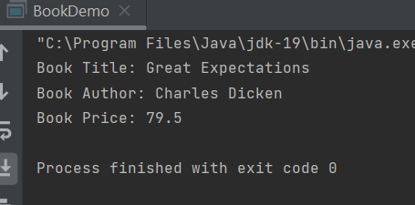
Task 3:
import java.util.Scanner;
public class task3 {
public static void main(String[] args) {
Scanner m = new Scanner(System.in);
Employee e1 = new Employee("Arham","Khan",25000);
Employee e2 = new Employee("Taha","Khan",12000);
System.out.println("the yearly salary of Employee 1 is "+ e1.getMonthlySalary()*12);
System.out.println("the yearly salary of Employee 2 is "+ e2.getMonthlySalary()*12);
e1.setMonthlySalary(e1.getMonthlySalary()*1.1);
e2.setMonthlySalary(e2.getMonthlySalary()*1.1);
System.out.println("The yearly salary of employee 1 after increment: "+ e1.getMonthlySalary()*12);
System.out.println("The yearly salary of employee 2 after increment: "+ e2.getMonthlySalary()*12);
}
}
class Employee{
private String firstName;
private String lastName;
private double monthlySalary;
Employee(String fn, String ln,double salary){
firstName = fn;
lastName = ln;
monthlySalary = salarycheck(salary);
}
public String getFirstName() {
return firstName;
}
public String getLastName() {
return lastName;
}
public void setMonthlySalary(double monthlySalary) {
this.monthlySalary = monthlySalary;
}
public double getMonthlySalary() {
return monthlySalary;
}
double salarycheck(double salary){
if(salary < 0.0){
return 0;
}else {
return salary;
}
}
}
TASK 3 OUTPUT:
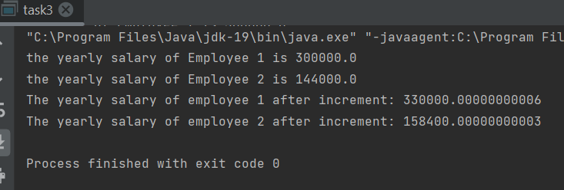
TASK 4:
import java.util.Scanner;
public class task4 {
public static void main(String[] args) {
Student s1 = new Student("Arham Khan","OOP in JAVA",19);
System.out.println("Name: "+s1.Name+"\n");
System.out.println("Course: "+s1.Course+"\n");
System.out.println("Age: "+s1.Age);
}
}
class Student{
public int Age;
public String Name;
public String Course;
Student(String name, String course, int age){
Name = name;
Course = course;
Age = age;
}
}

TASK 4 Output:
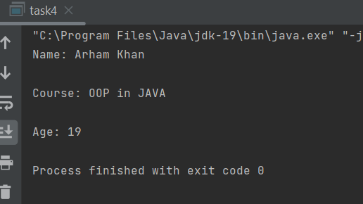

TASK 5:
import java.util.Scanner;
public class task5 {
public static void main(String[] args) {
int a;
Scanner m = new Scanner(System.in);
double Max = 0;
Manager[] Manager;
Manager = new Manager[3];
for (a=0;a<3;a++) {
System.out.println("Enter Employee Name " + (a + 1));
String name = m.next();
System.out.println("Enter Employee Number " + (a + 1));
int num = m.nextInt();
System.out.println("Enter Employee Phone Number " + (a + 1));
String phone = m.next();
System.out.println("Enter Employee Salary " + (a + 1));
double salary1 = m.nextDouble();
Manager[a] = new Manager(name, num, phone, salary1);
}
for(a=0;a<3;a++){
System.out.println("\nEmployee no "+(a+1)+" Details:");
System.out.println(Manager[a].toString());
}
for(a=0;a<3;a++){
double salary=Manager[a].getSalary();
if(Max<salary){
Max=salary;
}
}
System.out.println("\nMAX salary is "+Max);
}
}
class Manager{
public int empNum;
public String empName,empPhone;
private double salary;
public void setSalary(double salary) {
this.salary = salary;
}
public double getSalary() {
return salary;
}
Manager(String name, int empNumber, String phoneNum, double salry){
this.empName=name;
this.empNum=empNumber;
this.empPhone=phoneNum;
this.salary=salry;
}
public String toString(){
return "Employee Name: "+this.empName+"\nEmployee Number: "+this.empNum+"\nEmployee Phone No: "+this.empPhone+" \nSalary: "+Double.toString(getSalary());
}
}

OUTPUT TASK 5:
